Ukrainian
“Let Freedom Ring”
Bell

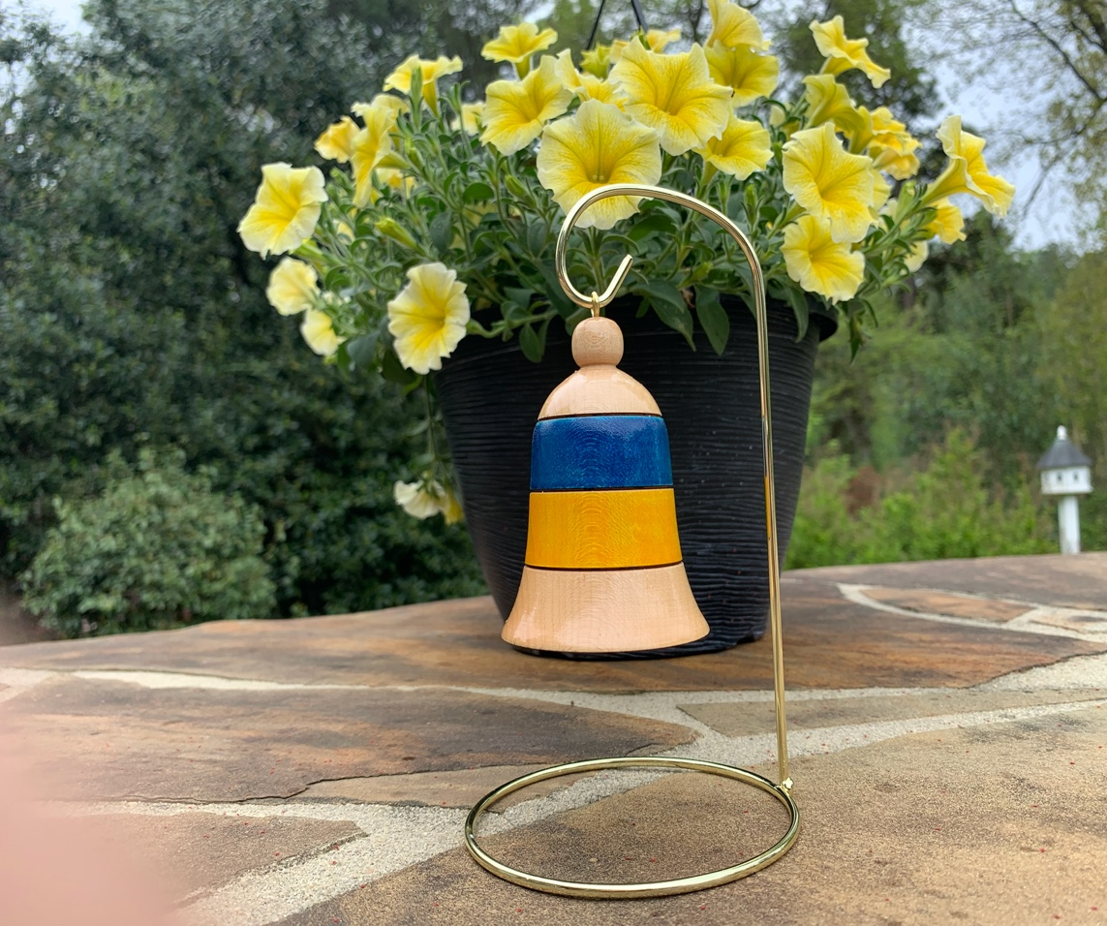

$100
In Honor of the People of Ukraine
Blue Chip Wood Turnings will donate the proceeds from every sale of the Ukrainian Freedom Bell *
to
Welcome House Refugee Resettlement
Check or Charge
Make Check Payable to Blue Chip Wood Turnings LLC
Order via USPS Mail: Blue Chip Wood Turnings
10509 Charmford Way, Raleigh, NC 27615-6569
Order via email: billbaxley@icloud.com
Call: 919-805-0060 with Charge Card Information
*Includes Stand

